TEMPLATE
Comparison investigation
(Box & Whisker plot)

Explore data using a statistical inquiry process (Internal)
NCEA Level 1

AS 91944
5 credits



1. Problem

How to use this template
For the 1.1 assessment, you will complete an investigation and write a report. The report you write will follow the PPDAC structure.
- Problem
- Plan
- Data
- Analysis
- Conclusion
If you are using this template, you have chosen to investigate a comparison of one numerical variable between two groups, using a box & whisker plot.
In the green boxes there is space for you to complete your report. The sentence starters are there to guide you, but you don’t have to use them.
In the red boxes there is an example report, written to excellence level.
The text that has been written in orange is key information to include for excellence, but may not be strictly necessary for students just trying to pass.
Investigative Question:
I wonder whether the median [numerical variable (unit)] is higher for [group 1] compared to [group 2] out of all [population].
I wonder whether the median height (m) is higher for rugby players who play as a ‘Forward’ compared to rugby players who play as a ‘Back’ out of all All Blacks players and Springbok players in the 2012/2013 season (from the NZGrapher dataset).

Background/purpose:
- What made you interested in studying this investigation?
- What is the purpose of the investigation - who will it be useful for?
- How widely could your results be applied?
For excellence, also include evidence of outside research.

In rugby, a team usually has 7 backs and 8 forwards. ‘Forwards’ usually take part in set pieces to contest for the ball such as a scrum and line out (https://www.activesgcircle.gov.sg/learn/rugby/rugby-positions-forward). ‘Backs’ tend to fill specialist roles in the outfield (https://www.activesgcircle.gov.sg/learn/rugby/rugby-positions-backs?tab=how_to_play).
I chose to do this investigation because I play rugby and wonder whether forwards or backs tend to be taller. In my team, it is mixed, but when I watch international rugby tests I notice that the backs tend to be shorter.
The results could be useful for coaching staff for international rugby teams when deciding whether a player might be more suitable as a forward or a back, depending on their height. It could also help players themselves (who want to play rugby professionally) determine whether they are under/over the expected height for their particular position, and potentially make a role switch.
Since the data only relates to NZ and South African players, it might be difficult to apply the results to all international rugby teams. For example, according to the Japanese national team squad lineup in 2025/2026 (https://www.ultimaterugby.com/japan/squad) the Japanese rugby side has an average height of 1.83m (71.42/39). This is lower compared to the average height of the Springbok side of 1.88m in 2025/2026 (93.88/50) (https://www.sarugby.co.za/sa-teams-players/springboks/). This might mean that my results can only be applied for All Blacks and Springboks, and not other teams.
Also, the data is from 2012/2013 which might made it difficult to apply to today’s rugby sides. However, I wouldn’t expect players’ heights to change too much between then and now.

Hypothesis:
- What might you expect to find in your investigation, and why?
I’m expecting that the median [numerical variable] will tend to be higher for [group 1 or 2] compared to [group 1 or 2].
This is because…

I’m expecting that the median height of players will tend to be higher for forwards than backs.
This is just based off what I’ve seen in professional test matches, where forwards like Scott Barrett (1.97m) and Ardie Savea (1.9m) tend to be taller than backs like Sevu Reece (1.79m) and Finlay Christie (1.77m).
Also, according to sources, “Forwards tend to be taller and heavier to generate power in scrums and mauls, while backs are generally leaner and faster to exploit space and handle quick passes.”(https://www.redbull.com/nz-en/rugby-union-player-positions-guide). This suggests that being tall is an important advantage of forwards, because it means they can generate more power. So, this research also suggests that the forwards will be taller.
2. Plan
Collection of data
- What source did you get the data from, or how did you collect it (and was it collected fairly/properly)?
- Is the data likely to be reliable?

The dataset is from the NZGrapher ‘Rugby’ dataset. It is real data collected by rugby website ‘RugbyHow’ for the 2012/2013 season.
It is difficult to know whether the data is reliable because RugbyHow isn’t an official/government website. We don’t have any information on how it was collected (for example whether reserve players were included). However, because the data can easily be recorded/checked using other internet sources, I believe it will be reliable.

Cleaning the data
- Was any ‘cleaning’ of the data required? (‘Cleaning’ is only required for data which was obviously recorded wrong or was incomplete).

No cleaning of the data was required because there wasn’t any incomplete data, and none of the data appeared to be incorrectly recorded.

Sampling
- Did you take a random sample of the dataset (i.e. only include, say, 30 data points)?

Out of the total population of 154 players I took a random sample of 50 forwards and 50 backs. I used the ‘random’ sample tool on NZGrapher to do this. Taking a random sample helped ensure there’s no bias in how the data is sampled.
Sources of variation
- Discuss at least two of the following sources of variation:
  - Natural/real variation
  - Occasion-to-occasion variation
  - Measurement variation
  - Induced variation
  - Sampling variation (only if you took a sample)
- How did you manage those sources of variation?

There might be occasion-to-occasion variation, which means that the same player might have a different height each time their measurement is taken. This is particularly for the younger players like Wallace Sititi, who could still have some growing to do. Also, players might switch between being forwards and backs, so they might be a forward at one point in time but switch to being a back. To manage this variation, the data only looks at players’ height at one particular point in time during the 2012/2013 season. We don’t know exactly when the data was taken but we can assume it was all done at the start of the season, so this variation should be managed.
Another type of variation is measurement variation. This is the variation that occurs because there might be differences in how a player’s height is measured, like different measuring equipment and methods. For example, whether the player was measured with or without shoes/socks. This variation is somewhat managed because International Rugby should have clear rules around how players’ heights are measured, so there should not be too much measurement variation.

3. Data
For help with drawing the graph on NZGrapher, see here.
Copy and paste your Scatter Graph from NZGrapher (or other) here. Make sure it includes:
- a title;
- labels on each axis;
- units on the x-axis;
- summary statistics;
- the blue DBM line and the green OVS line.

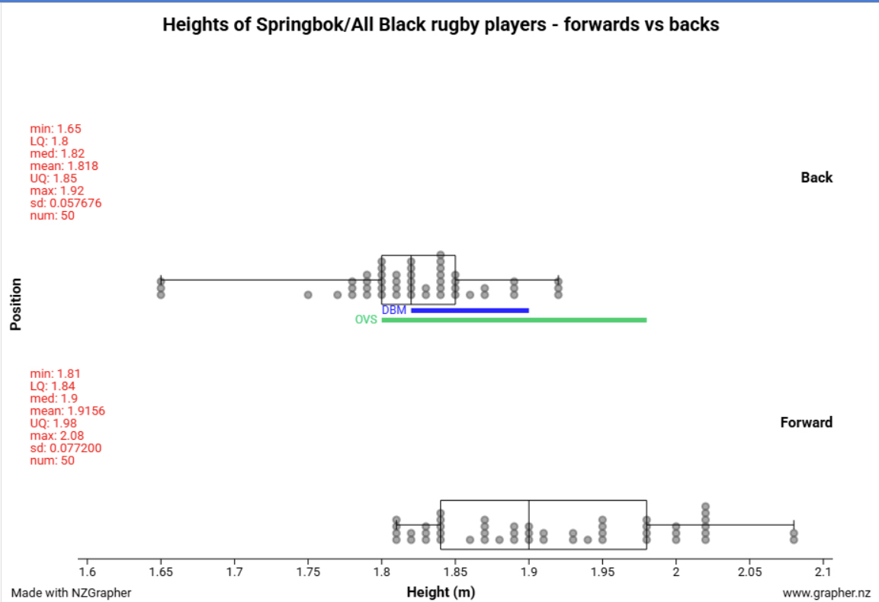

4. Analysis – Box & Whisker plot
Centre:
For centre, I notice that the median [numerical variable] for [group 1] is [median for group 1] and the median for [group 2] is [median for group 2]. This is a difference of [X].
This means that, [group 1] tends to have a [higher/lower] [numerical variable (unit)] than [group 2].
(optional) This [is/is not] what I expected because…
(optional) This [makes sense/does not make sense] because…

For centre, I notice that the median height for backs is 1.82m and the median for forwards is 1.9m. This is a difference of 0.08m.
This means that, forwards tend to be taller than backs by 8cm. I actually expected this difference to be slightly higher (about 15cm) based on watching the All Blacks lineup on TV, but this result does make sense as I didn’t do a full analysis of the current All Blacks lineup and it’s possible the forwards just appear bigger on TV than they actually are in real life.

Spread:
I notice that the IQR for [group 1] is [IQR for group 1] and the IQR for [group 2] is [IQR for group 2].
This means that the data for [numerical variable] of [group 1] has [more/less] spread than the data for [group 2].
(optional) This [is/is not] what I expected because…
(optional) This [makes sense/does not make sense] because…

I notice that the IQR for backs is 0.05m and the IQR for forwards is 0.14m.
This means that the data for the height of backs has a lot less spread than the data for forwards. I find this interesting as it shows that there’s a lot more variation in the heights of forwards compared to backs, which are much more concentrated around the 1.8m – 1.9m range.
This makes sense as forwards can still bulk up as much as they need to, regardless of their height. Backs, on the other hand, would struggle to be nimble enough the taller they get, so an ideal height for them might be around that 1.8m – 1.9m range.

Shift/Overlap:
I notice that the middle 50% of the data for [group 1] is shifted to the [left/right] of the data for [group 2]. There is [X] overlap between the two groups.
Because there is [a lot of/not much] overlap, it suggests that the middle 50% of [group 1] tend to be [similar/different] to [group 2].
(optional) This [is/is not] what I expected because…
(optional) This [makes sense/does not make sense] because…

I notice that the middle 50% of the data for backs is shifted to the left of the data for forwards. There is only 1cm overlap between the two groups (UQ of backs = 1.85m and LQ of forwards = 1.84m, so 1.85 – 1.84 = 1cm).
Because there is very little overlap, it suggests that the middle 50% of backs tend to be quite different to forwards.

Unusual Features:
- Any outliers?
- Any clusters?

There is an interesting cluster of 3 backs at the 1.65m mark. They are quite far away from the next tallest player, which is 1.75m. It is possible that these players play a particular position which has really low weight requirements, for example scrum half. Scrum halves don’t have much involvement in heavy collisions so they tend to be a lot smaller (see: https://www.rugbypass.com/articles/scrum-half-halfback-position-guide/). However, we can’t verify whether these 3 players are scrum halves as we don’t have specific data on this.

Making the call (DBM & OVS):
- For guidance with this, see here and here.
The Distance Between Medians (DBM) is [X] and the OVS is [Y].
For sample sizes of less than 100 per group: Because the DBM is [greater than/less than] 1/3 of the OVS, we [can/cannot] make the call that the [numerical variable] for [group 1 or 2] tends to be greater than the [numerical variable] for [group 1 or 2] out of all [population].
For sample sizes of 100 or more per group, up to 1000: Because the DBM is [greater than/less than] 1/5 of the OVS, we [can/cannot] make the call that the [numerical variable] for [group 1 or 2] tends to be greater than the [numerical variable] for [group 1 or 2] out of all [population].
For sample sizes of 1000 or more per group: Because the DBM is [greater than/less than] 1/10 of the OVS, we [can/cannot] make the call that the [numerical variable] for [group 1 or 2] tends to be greater than the [numerical variable] for [group 1 or 2] out of all [population].

The Distance Between Medians (DBM) is 0.08m (shown in blue on the graph) and the OVS is 0.18m (shown in green on the graph).
Because the DBM is greater than 1/3 of the OVS, we can make the call that the height (m) for forwards tends to be greater than the height for backs out of all All Blacks players and Springbok players in the 2012/2013 season (from the NZGrapher dataset).

5. Conclusion
Summary of analysis:
- Answer investigative question.
Overall, based on the OVS/DBM as discussed in the analysis, there [was/was not] sufficient evidence to make the call that [numerical variable (unit)] tend to be higher for [group 1] compared to [group 2] out of all [population].
Overall, based on the OVS/DBM as discussed in the analysis, there was sufficient evidence to make the call that the height (m) for forwards tends to be greater than the height for backs out of all All Blacks players and Springbok players in the 2012/2013 season (from the NZGrapher dataset).

Sampling variability (optional – only if you took a sample):
My analysis was based on a sample of [X] per group out of the population of [population size]. Because of sampling variability, if I were to take another sample of the same population, it is possible that I would get different results. However, because I took a large sample, the results will probably be roughly the same.
My analysis was based on a sample of 50 per group out of the dataset population of 135. Because of sampling variability, if I were to take another sample of the same population, it is possible that I would get different results. However, because I took a large sample, the results will probably be roughly the same.

Reflection:
- Was your hypothesis correct? Why or why not?
- What reflections do you have on the process?
- What else would be interesting to investigate (connected to what you investigated)?
- Are there any limitations to your investigation (and how widely your results can be extended)?
NOTE: This ‘reflection’ part is an important part of the criteria for getting excellence in this assessment. Try to show a deeper understanding of your results, think carefully about how they could actually be used, and talk about what biases/limitations might be at play.

Overall, my hypothesis was correct about forwards tending to be taller than backs out of all All Blacks players and Springbok players in the 2012/2013 season (from the NZGrapher dataset). This result can be expected from my observations of watching the All Blacks/Springbok test matches on TV. It also matches up with sources, for example in https://blog.networldsports.co.uk/rugby-union-positions-numbers-explained/ they explained that “The forwards are usually significantly larger and heavier, taller and have higher levels of body-fat relative to the backs, and use their size to gain ground, win possession of the ball in scrums and line-outs.”
In the future, it would be interesting to investigate how the heights of different particular rugby positions compare (e.g. scrum half compared to prop). This is because I noticed that, even within the forward packs/back packs, there seems to be a lot of variation in height depending on position. For example, I suspect the cluster of 3 backs all at 1.65m tall are scrum halves, but it’s not possible to confirm this without doing a full investigation. This investigation would be useful for coaches to have more specific information about the expected heights of particular positions, and also look at what height the highest performing players have.
One reflection I have on the process is that it might have been better to look at all international rugby teams, not just All Blacks and Springboks. This is because different nationalities have biological differences which mean that their players have different builds. This can be seen on this statistics website which shows that the average height of boys ranges from 160cm (Timor-Leste) to 184cm (Netherlands) - https://worldpopulationreview.com/country-rankings/average-height-by-country.
Some limitations for this analysis is it might not be useful for amateur rugby coaches because the build of professional athletes is likely to be different to amateur rugby players. It might still be useful for provincial rugby competitions and Super Rugby because those players are professional. Another limitation is that the results are limited to being relevant to Springboks and All Blacks, not all countries.

